OPENING A PULL REQUEST and MERGING AND DEPLOYING TO MAIN BRANCH

- Click on ‘Compare & pull request’ on top-right hand side of the page
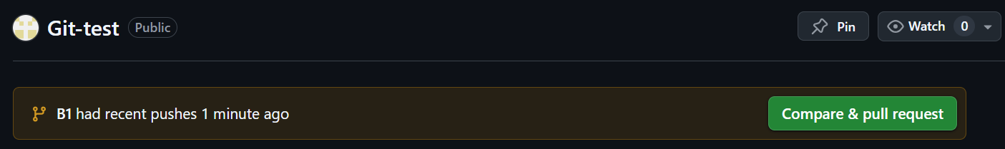
The ‘Open pull request’ window appears - see image below
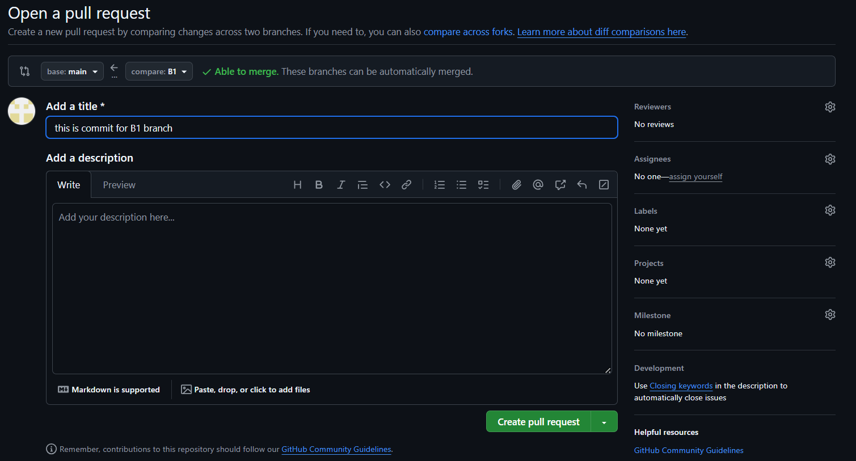
- Enter a ‘title’ in the top text box
- Add brief description about the request in the description field
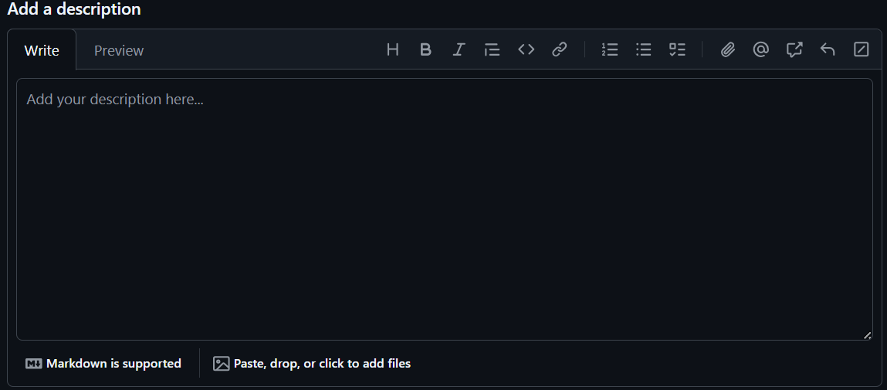
- Click ‘Create pull request’


GitLab will automatically check for conflicts. If there are no conflict, to shows a conformation message


- Click on ’Merge pull request’


The following confirmation window appears
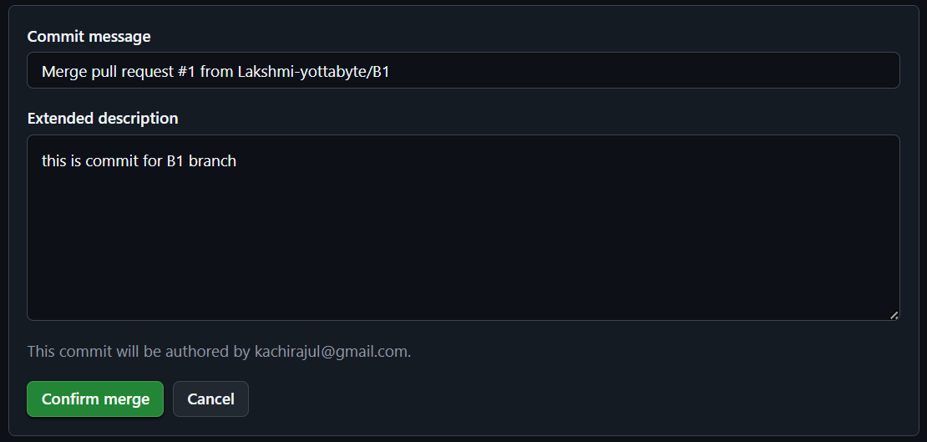
- Click ‘Confirm merge’ to merge the changes to the ‘Main branch’. Once it merged, the following message appears

- Add a comment in the comment box
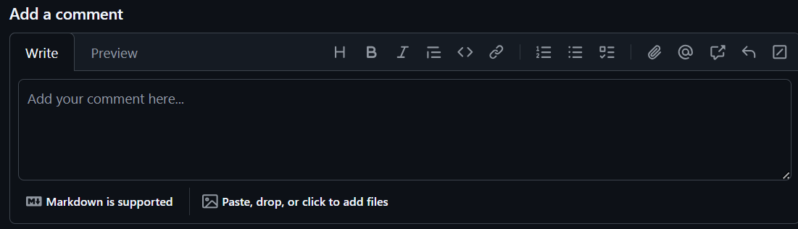
- Click on ‘Close pull request’ to close the request and complete the process.


